Host Countdown
~ 6 steps to a successful Workshop ~
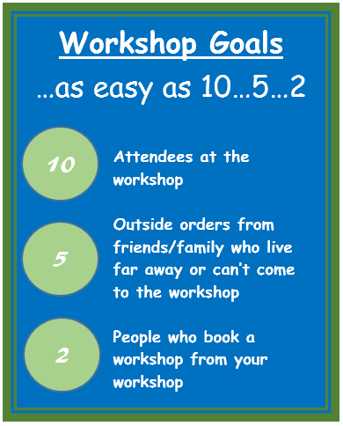
You’re awesome! Thank you SO much for being my partner for this workshop.
You should feel really good about sharing this important health information with friends and family.
My workshops are super fun & interactive. My main goal is to empower people with the knowledge to keep themselves and their family safer!
Another goal, though, is to get the Pure Haven Products into as many families homes as possible. This is good for my business, the wellbeing of your loved ones, the environment and your host rewards! Wouldn’t it be awesome to know you helped decrease the “body burden” of your friends and family?

Let’s do this!
 |  |  |  |  | Your own countdown dates
Connect & Invite | 3-6 weeks in advance  Step 1 | Set a date for workshop  Fill in the Countdown to your own dates for each of these steps. Use your workshop date and work backwards to actually write in the “Your own countdown dates” blanks. THEN, put those reminders in your cell phone. Life is busy and we get one shot at this so organization is key!  Use your FRANKO list (see party planner) to brainstorm 30-40 people you can invite. That may sound like a lot but only about 1 in 8 will come. Make sure to invite from all areas of your life, not just one group of friends. It’s more fun and more informal when more people come and they’ll like meeting new people too!  Send a text or private message to everyone you want to invite. Tell them you’re going to send an invite their way for a workshop you’re really excited about. Explain a little about the company and what you like about it. Add is a piece, if you can, that personalizes it for them specifically, like, “I just know you’ll love the Baby Cream for Sawyer because I know you’ve been looking for safe products…”  Then invite everyone on your list from the Facebook event page. (even invite people who live far away to the event page. You can let them know that even though they can’t physically come to the workshop, they’ll learn about the company and products a little through the posts on this page and can place an order before the party. |  |  | ________
Energize & Personalize |  | 2 weeks in advance  Step 2 | Add the addresses to your FRANKO list and text me a pic so I can send invites through the mail. I’ll take care of all that! (Layering invites really helps attendance)  If you don’t have addresses and you feel comfortable, message those friends. Explain that you’d love to send them an actual invitation and ask if that date is good for them.  Make sure to comment on each post I make on your Facebook event page. Share your excitement! (this increases the reach of posts) and tag friends you think would appreciate that post.  Stay really  Plan what you want to serve for snacks and drinks. Please make these easy, fast finger foods. I don’t want this to be a huge undertaking for you, plus I want the foods to be easy for participants to eat during the presentation and most importantly, I want others who are thinking about hosting to know it’s not hard and they don’t have to go all out! It is great though, if you have an idea of a theme, especially if it goes along with the day of the week for your party… “Margarita Monday” “Taco Tuesday” “Wine Wednesday”  As you touch base with people |  | 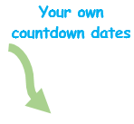  ________
Reach out | 1 week in advance  Step 3 | 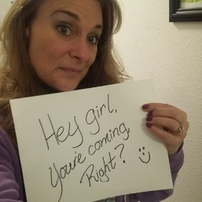  This is a fun one! Take a pic of yourself holding a sign just like this! Make it fun/goofy. Text or Facebook message this pic personally to each individual person on your list who hasn’t responded or said “maybe”.  Take a  As you touch base with people remind them to bring a friend – so much fun to do that and it’ll really increase the attendance a lot. They’ll each get a free gift from me!  As you touch base with people  If you don’t responses, especially on Facebook, give them a call on the phone.  Grocery shop for snackies & drinks.  As you touch base with peopleShop  Work on getting those outside orders completed.  Consider going live on the FB event! Show products you use and why you love them, share why you’re excited & any party plans that might excite guests. |  |  | ________
 | Remind & Excite | Day before  Step 4 | Do reminder calls or texts to everyone on the “going” list and “maybe” list. If we set up the event on Facebook without your address, this is a good time to give it to them. Let them know you’re excited to see them tomorrow and ask if they’re bringing a friend.  As you touch base with people  Think about set-up. We can do the workshop in your living room or around your kitchen table (or Island). If we’ll be in the living room then I just need a little table to put products on. Let me know what you think would work best.  As you touch base with people |  | ________
Have Fun  Step 5 | Day of workshop | I will probably arrive 35 minutes early. I’ll want to visit about who’s coming, what you think they’d like and who might be interested in booking a party.  As you touch base with people |  |  | ________
 | Follow up | 1-4 days after  Step 6 | Text or call anyone who hasn’t placed their order and ask if there’s anything they’d like. You can, if you live close, offer to add items from their wish list to your order to save on shipping if you want  As you touch base with peopleText people who haven’t ordered and ask if there’s anything they’d like.  This is the FUN part! Complete you order with me for your host rewards!  As you touch base with peopleThis is the fun part! |  | ________
You’re going to Rock this! Sincere Thanks, Krissie

